**GREEN RESILENT AND SMART SHOMOLU, (G.R.A.S.S CITY)**

**MAST ER PLAN (2018-2038)**

COMPREHENSIVE DATA ANALYTICS AND VISUALIZATION

|  |  |  |
| --- | --- | --- |
| Gender | | |
|  | Frequency | Valid percentage |
|  |  |  |
| Male | 101 | 56.4 |
| Female | 78 | 43.6 |
| Missing | 2 |  |
| Total | 181 | 100 |

From the above we can see that majority of the respondents are male with 56.4% (101) of the respondents being male and 43.6% (78) accounting for female.

|  |  |  |
| --- | --- | --- |
| Number of households per building | | |
|  | Frequency | Valid percentage |
| 2 | 9 | 5.4 |
| 3 | 17 | 4.4 |
| 4 | 22 | 12.2 |
| 5 | 119 | 65.7 |
| Missing | 14 |  |
| Total | 181 | 100 |

It is observed from the above table that majority of the buildings or compounds is congested as it consists of more than 5households per building with 119 of the respondents (65.7%), with 12.2%, 5.4% and 4.4% amounting for 4, 2 and 3 households per building respectively. This explains the kind of settlement pattern in the area.

The common mode of transportation in this local government area is public vehicles and this can be understood through the interconnectivity between various sections in the area. All other mode of transportation except private vehicle which amounts for 24% of the respondents are all considered public modes of transportation.

The settlement pattern in this local government area as is predominant in lagos state is nucleated, whereby people live in compact areas where they can easily recreate as well as work.

|  |  |  |
| --- | --- | --- |
| Drainage condition | | |
|  | Frequency | Valid percentage |
| Good | 41 | 23.6 |
| Fair | 73 | 42 |
| Poor | 36 | 20.7 |
| Bad | 24 | 13.8 |
| Total | 174 | 100 |
| Missing | 7 |  |

The drainage condition of the area is said to be fair as observed and reported. In 23.6% of the local government area the drainage condition is good, poor in 20.7% and bad in 13.8% of the area.

From the above chart, the age distribution of the respondents in the local government area is predominantly over 50, this can be explained because of the settlement pattern of the area, it is said to be nucleated and thus can be attributed to a kind of family house settlement type.

The predominant educational attainment of the respondents in Somolu local government area are senior secondary school certificate (42.8%) and (38.7%).

The prevalent social vice in Somolu local government area is as reported delinquency which includes cultism and the likes as it amounts for 35.8% of the social vices reported in the area while robbery (27%), burglary (29.2%), rape (0.9%) and others (10.4%) amount for the prevalent social vice in the area.

As stated earlier the settlement pattern of Somolu local government area is nucleated that is, compact and it has been established that the number of households per building is such that the buildings are congested. This confirms or explains the housing condition of buildings in the area as most respondents were affixed on whether the condition of buildings were good or fair (46% - 80 persons & 42.5% - 74 persons respectively).

|  |  |  |
| --- | --- | --- |
| Availability of police post | | |
|  | Frequency | Valid percentage |
| Yes | 82 | 46.9 |
| No | 93 | 53.1 |
| Total | 175 | 100 |
| Missing | 6 |  |

There is a difference in percentage of respondents who live within 800m of a police post and this is evident in the table above. This is understood with 53.1% of respondents stating that there is no police post within 800m.

As the table depicts there is virtually no civic center in the local government area as 96.9% of the respondents reported that there is no civic center within every 800m of the local government area.

|  |  |  |
| --- | --- | --- |
| Availability of Banking Facilities | | |
|  | Frequency | Valid Percentage |
| Yes | 51 | 29.1 |
| No | 124 | 70.9 |
| Total | 175 | 100 |
| Missing | 6 |  |

Out of the 181samples to be taken 6 persons didn’t answer the questions, accounting for the missing values on the table.The absence of banking facilities within 800m walk from the area of most of the respondents were rightly communicated through the questionnaire with 70.9% of the respondents saying that there are no banking facilities within every 800m of the area.

|  |  |  |
| --- | --- | --- |
| Availability of post office | | |
|  | Frequency | Valid percentage |
| Yes | 51 | 29.1 |
| no | 124 | 70.9 |
| Total | 175 | 100 |
| Missing | 6 |  |

This also shows that there are little or no post office within every 800m of the local government. 70.9% (124) of the respondents lament the absence of post office within 800m of the site.

The table depicts that 77.7% (136) of responses were on the fact that there are no telecommunication masts within 800m of the site.

The table above shows that nursery and primary schools are very much available in Somolu local government area with a percentage of 89.1% of the total number of respondents met said that there is at least a nursery or primary school within every 800m in the local government area.

|  |  |  |
| --- | --- | --- |
| Availability of Secondary School | | |
|  | Frequency | Valid Percentage |
| Yes | 100 | 57.1 |
| No | 75 | 42.9 |
| Total | 175 | 100 |
| Missing | 6 |  |

In some parts of Somolu 57.1% (100) of the respondents agreed to have at least a secondary school within every 800m of their residence, while a few others that is 42.9% of the respondents disagreed to having at least a secondary school within 800m of their residence.

The table above evidently shows that recreational facilities are lacking in Somolu local government with 89.7% (157) respondents agreeing to the fact that there are no recreational facilities within 800m especially in most part of Somolu. However, 10.3% (18) of the respondents disagreed to not having recreational facilities.

The chart and table shows that there is little or no fire station within every 800m of the local government area as 97.7% of the respondents indicated while 2.3% of the respondents said otherwise.

From the chart and table above it is evident that the condition of refuse dump in somolu local government area is fair by 30.1% (52 respondents) whereas 24.3% (42respondents) said there are no refuse dumps available.

The chart above shows that 162 of the respondents accounting for 92.6% of the respondents have no shopping center within 800m of their residence while 13 of the respondents said otherwise, this suggests that in some places in somolu local government there are shopping centers but they are not enough for the populace.

From the chart above it is clearly evident that a good number of drainages are paved as gathered from 92 respondents (52.9%). It is closely followed by unpaved drainages which account for 73 respondents (42%) and 9 respondents (5.2%) have no drainage.

The frequency table above shows that 54% of the respondents recognize local vigilante as the major form of security in the local government area while the police amount for 26.4%, no security agency amounts for 13.2% and others 6.3%.

The chart above shows that the security personnel in the local government area which is local vigilante is effective as illustrated in the response of 76% of the respondents.

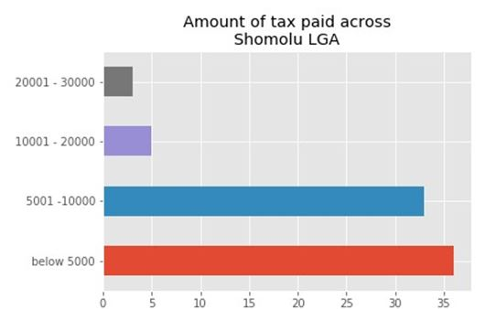

The horizontal bar graph above shows the distribution of the amount of tax paid by respondents across the Local government area.

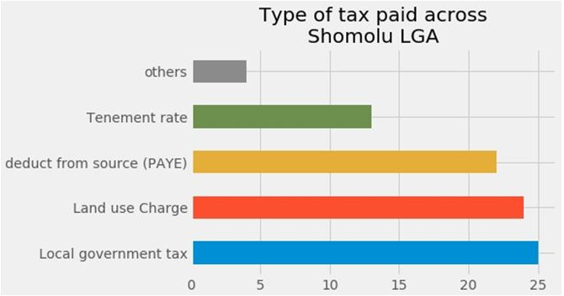

The above visualization shows the dominant amount of tax paid in Shomolu LGA to be the

Local government tax, seconded by the land use charge.

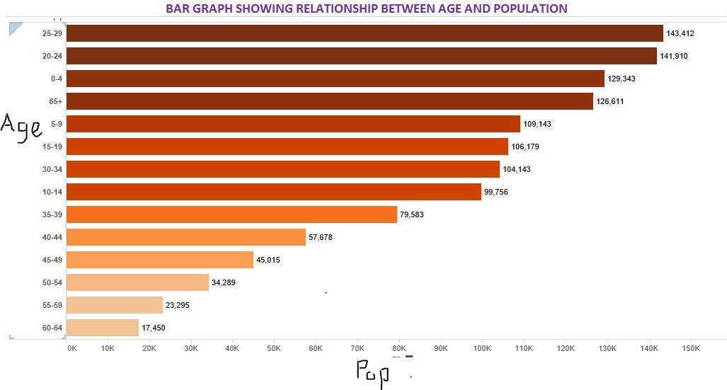

**The Bar graph above shows us the current age group and their corresponding population for shomolu LGA.**

from the visualization above, it could be inferred that the most common age group in the study area is the 26 - 29 age group, closely followed by the 20 - 24 age group, then the children age group coming third. this means that there is a large population of youths and labor force in shomolu LGA. it would also give us insight to provide enough job opportunities for youths in the area which would be incorporated in the master plan report.

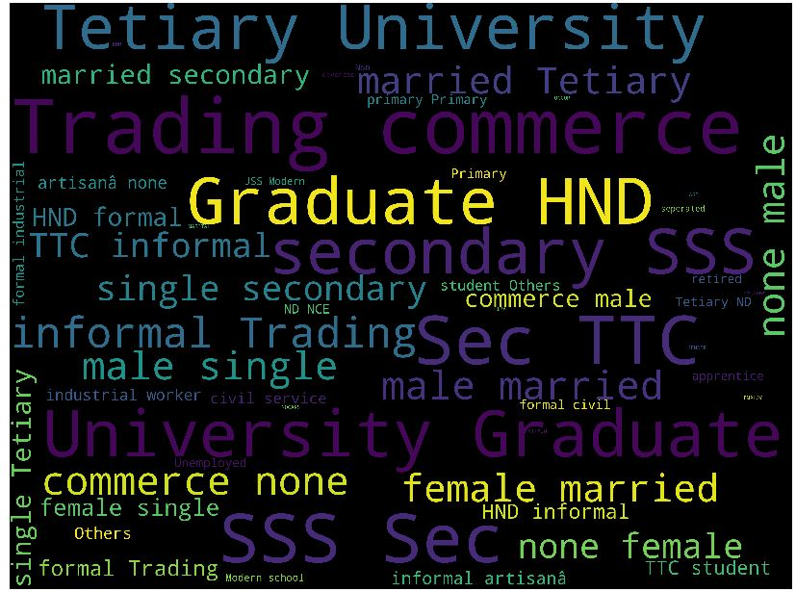

**Creating a word cloud showing the most frequently occurring response from the questionnaire dataset.**

From the word cloud visualization projected above, it could be seen that graduate, HND, University, Tertiary and trading, are boldly written to signify their number of occurrence. So from this, it could be concluded that, majority of the people in Shomolu are either Graduates, HND holders, and traders.

**TRENDS IN POPULATION GROWTH**

|  |  |  |  |  |  |  |
| --- | --- | --- | --- | --- | --- | --- |
| 1996 | 2006 | 2016 | 2026 | 2036 | 2046 | 2056 |
| 290,019 | 403,569 | 555,671 | 765,101 | 1,053,463 | 1,450,508 | 1,997,196 |

**Hypothetically estimated population at a 10 year interval from 1996 till 2056.**

Shomolu LGA Age and Sex Structure (**2006**)

|  |  |  |  |  |
| --- | --- | --- | --- | --- |
| **Age Group** | **Male Population** | **Female Population** | **Total Population** | **Percentage** |
| **0-4** | 23,164 | 23,316 | 46,480 | **15.2** |
| **5-9** | 19,524  17,241 | 19,680 | 39,221 | **12.7** |
| **10-14** | **17,241** | 18,607 | 35,848 | **10.3** |
| **15-19** | **18,668**  **2222222** | 19,489 | 38,157 | **9.1** |
| **20-24** | 26,039 | 24,957 | 50,996 | **9.8** |
| **25-29** | 26,829 | 24,707 | 51,536 | **10.2** |
| **30-34** | 20,236 | 17,099 | 37,425 | **8.3** |
| **35-39** | 15,684 | 12,915 | 28,599 | **7** |
| **40-44** | 11,151 | 9,577 | 20,728 | **5.3** |
| **45-49** | 8,922 | 7,255 | 16,177 | **4** |
| **50-54** | 6,266 | 6,057 | 12,323 | **2.8** |
| **55-59** | 4,616 | 3,756 | 8,372 | **1.7** |
| **60-64** | 3,372 | 2,900 | 6,272 | **1.3** |
| **65+** | 5,700 | 5735 | 11,435 | **2.3** |
| **Total** | 207,519 | 196,050 | 403,569 | **100%** |

|  |  |  |  |  |
| --- | --- | --- | --- | --- |
| **Age Group** | **Male Population** | **Female Population** | **Total Population** | **Percentage** |
| **0-4** | 34,001 | 34224 | 68225 | **15.2** |
| **5-9** | 28683  17,241 | 28887 | 57570 | **12.7** |
| **10-14** | **25,307** | 27312 | 52619 | **10.3** |
| **15-19** | 27,401  **2222222** | 28606 | 56007 | **9.1** |
| **20-24** | 38,221 | 36633 | 57484 | **9.8** |
| **25-29** | 39,380 | 36266 | 75646 | **10.2** |
| **30-34** | 29835 | 25098 | 54933 | **8.3** |
| **35-39** | 23021 | 18957 | 41978 | **7** |
| **40-44** | 16367 | 14057 | 30424 | **5.3** |
| **45-49** | 13096 | 10649 | 23745 | **4** |
| **50-54** | 9197 | 8890 | 18087 | **2.8** |
| **55-59** | 6775 | 5513 | 12288 | **1.7** |
| **60-64** | 4949 | 4256 | 9205 | **1.3** |
| **65+** | 58366 | 8418 | 16784 | **2.3** |
| **Total** | 304606 | 287,771 | 592,377 | **100%** |

Shomolu LGA Age and Sex Structure (**2018**)

|  |  |  |  |  |
| --- | --- | --- | --- | --- |
| **Age Group** | **Male Population** | **Female Population** | **Total Population** | **Percentage** |
| **0-4** | 64460 | 64883 | 129343 | **15.2** |
| **5-9** | 54378  17,241 | 54765 | 109143 | **12.7** |
| **10-14** | **47977** | 51779 | 99756 | **10.3** |
| **15-19** | **51947** | 54232 | 106179 | **9.1** |
| **20-24** | 72460 | 69450 | 141910 | **9.8** |
| **25-29** | 74658 | 68754 | 143412 | **10.2** |
| **30-34** | 56562 | 47581 | 104143 | **8.3** |
| **35-39** | 43644 | 35939 | 79583 | **7** |
| **40-44** | 31029 | 26649 | 57678 | **5.3** |
| **45-49** | 24827 | 20188 | 45015 | **4** |
| **50-54** | 17436 | 16853 | 34289 | **2.8** |
| **55-59** | 12844 | 10451 | 23295 | **1.7** |
| **60-64** | 9382 | 8068 | 17450 | **1.3** |
| **65+** | 110652 | 15959 | 126611 | **2.3** |
| **Total** | 304,606 | 545,567 | 1,123,050 | **100%** |

Shomolu LGA Age and Sex Structure (**2038**).

**PROBLEM IDENTIFICATION**

A problem can be regarded as a difference between the actual situation and the desired situation. This means that in order to identify a problem the team must know where it is meant to be and have a clear understanding of where it currently is in relation to the perceived problem.

The problem identification map is the map that shows the identified problems in each streets, road, drainage, and buildings of the study area. These problems are being broken down into various problems which includes:

• road problem identification

• drainage problem identification

* Building problem identification

**ROAD PROBLEM IDENTIFICATION**

This is the map showing the identified problems of road on the study area. Certain problems were identified on each street which were.

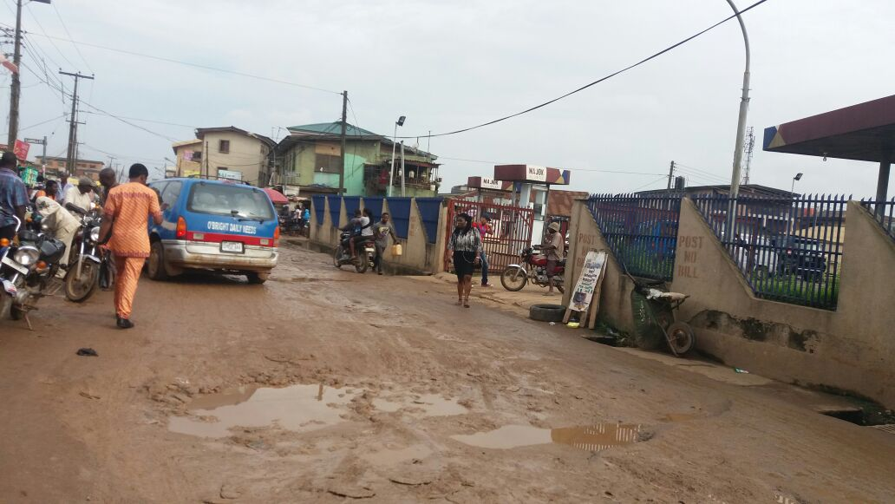

Bad and untarred roads at Olarenwaju

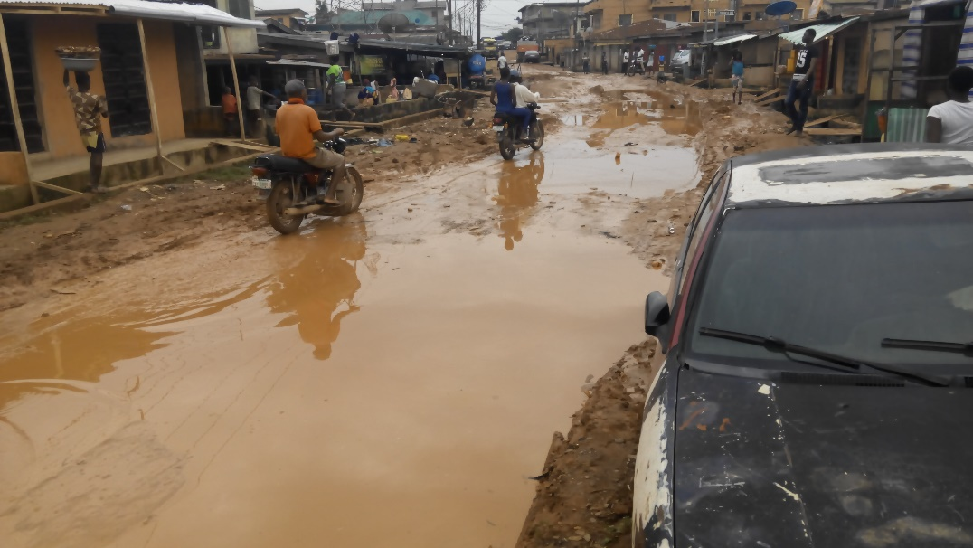

Untarred and water logged road.

Impeding movements.

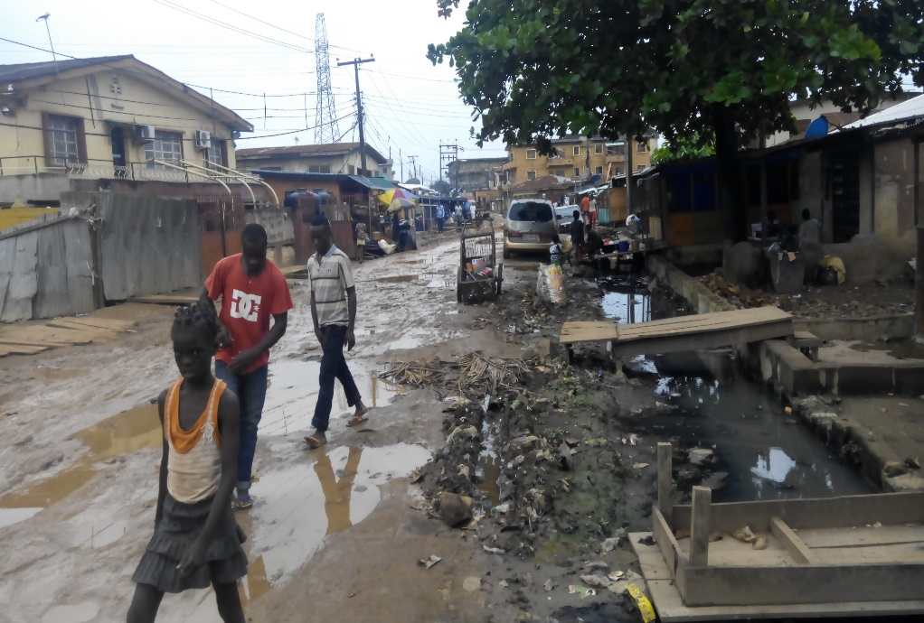

**DRAINAGE PROBLEM IDENTIFICATION**

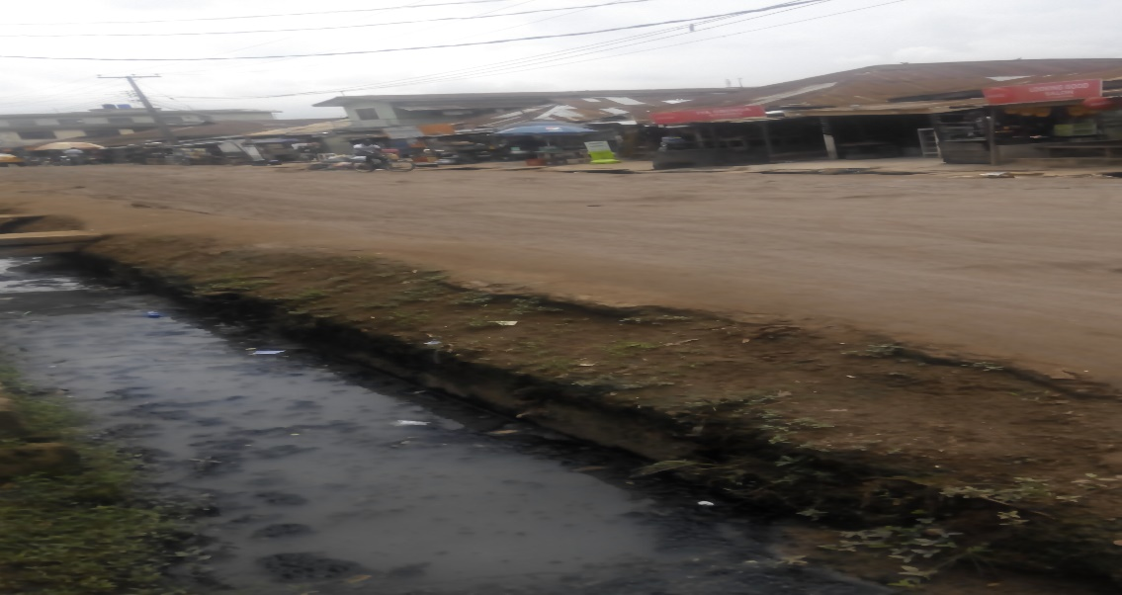

Opened and blocked drainage

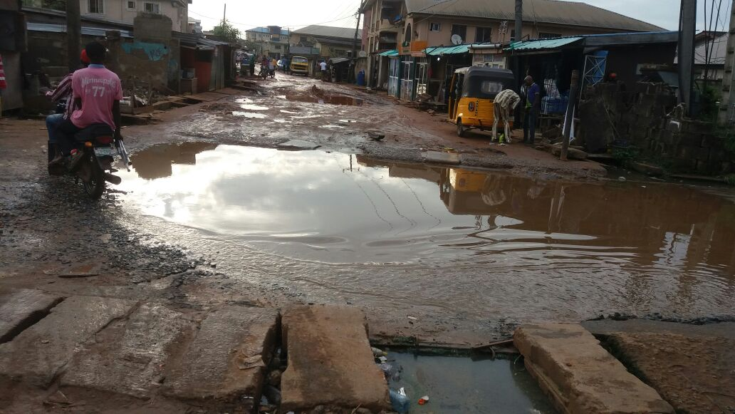

**BUILDING PROBLEM IDENTIFICATION**

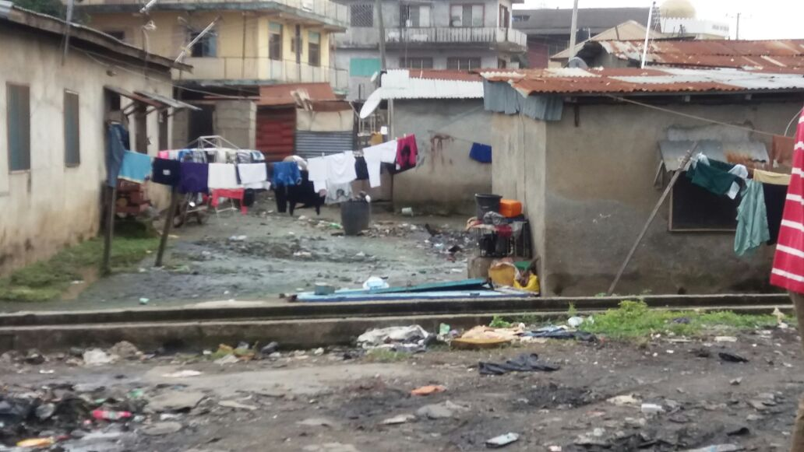

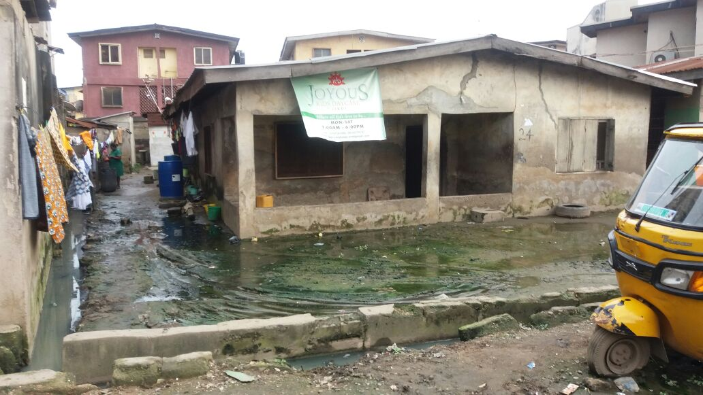

**OTHER PROBLEM IDENTIFICATIONS**

|  |  |  |
| --- | --- | --- |
| **PROBLEM TYPE** | **PROBLEM IDENTIFIED** | **LOCATION** |
| DRAINAGE  PROBLEM | The land area close to mabinu ori close is a marshy  area which leads to flooding of kolawole Deborah street. Absence of drainage which encourages stagnant water on in the area during rainy season. | Mabinu ori close |
| ACCESSIBILITY  PROBLEM | Houses close to the river are in bad condition and are  scattered with no road linking to each house. Access to these houses are by footpath, the residents lack access to good portable area. | Beside the river |
| ROAD PROBLEM | The tail end of the palace road is in very bad condition  and also has a steep terrain. | Palace road |
| ACCESSIBILITY  PROBLEM | The houses situated in between Samuel olabode street  and ajegunle street doesn’t have proper access and are  clustered. | Between Samuel  olabode street and ajegunle street |
| ROAD PROBLEM | There is a Y-junction at the end of isheri road. | Isheri road. |
| ROAD PROBLEM | Some road in leye pratt and adejokun street are tarred  while some aren’t. | Leye pratt and  adejokun street |

|  |  |  |
| --- | --- | --- |
| **PROBLEM**  **TYPE** | **PROBLEM IDENTIFIED** | **LOCATION** |
| ROAD PROBLEM | The road at the end of wilmer street is bad, has big potholes and  doesn’t have access to another street. | Wilmer street |
| PARKING  PROBLEM | There is no park for denro-ishabi buses, so they park on kosoko  road. | Kosoko road. |
| ROAD CARRIAGE  CAPACITY PROBLEM | Kosoko road width is insufficient for the carriage capacity. | Kosoko road |
| CONFLICTING  LAND USE | Presence of commercial activities on the kosoko road as well  as insufficient motorcycle | Kosoko road |
| PARKING  PROBLEM | Parking space causes high pedestrian traffic especially during  rush hours. | Isheri road. |
| CONSTRUCTION  PROBLEM | Major road, drainage and pedestrian bridge construction  temporarily hinders vehicular movement. | Ojodu-berger |